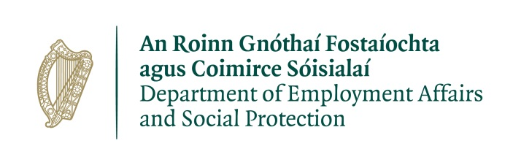
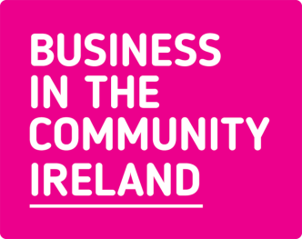
Business in the Community Ireland (BITCI), the leading business network on sustainable and responsible business practice, is seeking to recruit a Job Coach for Maternity Cover in our EmployAbility service Ready for Work. This is a minimum 7 month contract, with the potential to be extended.
Our purpose is to inspire and enable business to bring about a sustainable, low carbon economy and a more inclusive society where everyone thrives. We provide expertise and independent advice, develop forums for collective action and create programmes that make real impact.

Our values
- We have the courage to do the right thing - We challenge ourselves and everyone we work with to build a better future
- We have each other’s back - We build each other up, we listen and we share our expertise
- We’re ahead of the curve - We always stay one step ahead. We inspire others to look beyond the horizon
- We’re all in - We believe in our purpose and we never give up
- We know our stuff - We’ve been leading the sustainability agenda for two decades

Ready for Work is BITCI’s EmployAbility Service, funded by the Department of Social Affairs and Social Protection. There are 24 EmployAbility Services in Ireland, 4 in Dublin (https://www.gov.ie/en/service/8578c4-access-the-employability-service/).
The aim of the service is to support people with a health issue, illness, injury or disability into employment. The service also supports employers by matching suitable jobseekers to vacancies, providing ongoing support for both the employer and employee throughout employment, and offering advice and information on additional employment supports such as the Wage Subsidy Scheme.
This service is one of a suite of Employment Programmes managed by BITCI which support the aims of BITCI’s Inclusive Employer Blueprint (https://www.bitc.ie/the-leaders-group/the-inclusive-employer/).
Job Description
Job Title: Job Coach
Contract Type: Maternity Cover, full time (35 hours per week) to at least July 2020
Office Location: Phibsborough, Dublin 7
Job Purpose: To support jobseekers with a health issue, injury, illness or disability towards employment by providing one to one guidance and facilitating group employability training; also to engage with businesses to match jobseekers to job opportunities and support employer and employee in sustaining employment.

Responsibilities
- Manage a case load of jobseekers with health issues or disabilities towards achieving employment and related outcomes
- Maintain a referral stream to the service by building and maintaining relationships with Intreo and Local Employment Services staff plus organisations working with people with disabilities
- Develop and maintain relationships with businesses (BITCI member companies and others) to source opportunities, match suitable clients, and support both company and employee during employment
- Assess the needs of individual clients and determine their work aspirations, experiences, skills and potential barriers
- Develop and implement individualised plans to support successful outcomes over an 18 month period
- Where possible and needed, help the employer to carve a role for the client and provide on-the-job support
- Work with the EmployAbility Service Co-ordinator to facilitate group employability training
- Proactively work with BITCI colleagues involved in the Inclusive Employer to ensure the best outcomes for businesses and clients
- Maintain detailed records and provide regular reports against targets to funders
- Learn from research and consultation with stakeholders to develop best practice
- Other tasks as required.

Skills and Knowledge
- Experience of supporting people into employment
- An understanding of the particular issues facing people with disabilities or health issues in finding and maintaining employment
- Experience of managing a case load of clients
- A thorough understanding of how to succeed in jobseeking, including CVs, approaching employers and use of social media
- A good knowledge of issues and concerns for employers and the Irish employment market
- A Diploma or Higher in Adult Guidance & Counselling or equivalent is an advantage
- Knowledge of organisations working to support people with disabilities would be useful
- Knowledge of Business In The Community Ireland

Personal Attributes and competencies
- Client-driven attitude and professional demeanour
- Empathy and ability to support individual and business change
- Strong relationship management and networking skills
- Highly motivated and enthusiastic
- Excellent team working combined with the ability to work on your own initiative
- Strong oral, written and presentation skills
- Competent user of Microsoft Office suite, particularly Microsoft Excel
What we offer
- Generous Annual leave: 22 days annual leave per year, pro rata
- PRSA: Option to join the Company’s PRSA scheme after six months' service
- Flexible working practices
- Training and Development Opportunities
- Volunteer days: two days paid volunteering leave per annum, pro rata
- Access to our Employee Assistance Programme

How to apply
Please email your CV and cover letter to Therese Donovan at careers@bitc.ie by midnight on Monday 6th January 2020 with “Application – EmployAbility Job Coach Maternity Cover” on the subject line of your email.

Business in the Community Ireland is an equal opportunities employer. We have a policy of interviewing candidates with disabilities who meet the essential criteria. Please let us know of any accommodations needed in order to attend for interview.
Please note that you must hold current eligibility to work in Ireland to be considered for the role.

EmployAbility Services are funded by the Irish Government through the Department of Employment Affairs and Social Protection.

