Employment Programmes Application Form
- Personal Details
First name: | Surname:
Address:

Mobile: | Other phone:
Email address:
Gender: | Date of Birth:
Country of birth:
- If If your country of birth is not Ireland, when did you arrive in Ireland?
(month and year)

- Referral Details
Are you linked in with a referring agency/ support agency? Yes ☐ No ☐
If yes, please ask your support worker to complete this section:
Name of referring support agency:
Address / site of referring support agency:

Name of support worker:
How does your client demonstrate they are ready for work? (include examples of how the client has moved on;
positions of responsibility; timekeeping; reliability and behaviour)

I confirm that this client has been risk assessed ☐
Support worker phone no:
Support worker email address:

FOR OFFICE USE ONLY | Date: | Assessed by:
Proposed Service: RFW EPIC RISE
English Test: Oral: % Written: %
Proof of residency status:

EU/Irish Passport Asylum Seeker with work permit Other ID None

GNIB card with Stamp 4 Reason for Stamp 4: __________________________

GNIB card with Stamp 1g GNIB Expiry Date: ___________________________
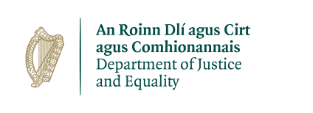
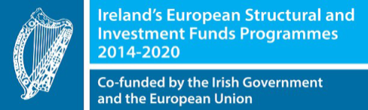
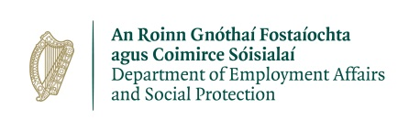

EPIC is co-funded by the Department of Justice and Equality and the European Social Fund under the Programme for Employability, Inclusion and Learning 2014-2020 .
under the Programme for Employability, Inclusion and Learning 2014-2020
- How did you hear about us?

Referral agency ☐ I know someone who attended the programme ☐
Friend ☐ Internet ☐ Other ☐

Please explain:

- Employment

- Are you unemployed? Yes ☐ No ☐

- If yes, how long have you been unemployed in Ireland? (month and year) _____________________

- If you are employed, please give details of your job.
Role ___________________________________ Days per week ______ Hours per day _________

- What types of employment are you looking for? E.g. retail, construction, IT, customer service etc.
___________________________________________________________________________________

- Do you have a CV? Yes ☐ No ☐ (If yes, we will ask for your CV at a later stage)

- Education / skills

- Please tick all the levels of education you have completed
Primary School ☐ Secondary School/High School ☐
Further Education / FAS / FETAC ☐ Degree ☐
Postgraduate (Masters/PhD) ☐

- If you have a Further Education, Degree or Postgraduate qualification please give details:-
- What qualification do you have (including subject)? __________________________________________
- Did you complete it in Ireland? Yes ☐ No ☐
- How long did your qualification take? __________________________________

- How strong are your IT skills? Circle or highlight a number on the scale (1= low, 5 =high) 1 2 3 4 5

- What can you do on a computer? Please list:

- If English is not your first language, do you have any English language qualification? Yes ☐ No ☐

- If yes, what is your qualification? ______________________________ _________________________ What year did you get it? _________

- Do you have a valid Irish driving licence? Yes ☐ No ☐

- Your current situation
- Are you receiving a social welfare payment? Yes ☐ No ☐
If yes, please give details of payment ___________________________________________
- Are you currently living with your partner and/or other family member(s)? Yes ☐ No ☐
- If yes, is your partner and/or other family member(s) currently working? Yes ☐ No ☐
- Do you have any children who are dependent on you? ______ If yes, how many? ____________
- Are you parenting alone (single parent)? Yes ☐ No ☐
- Do you have commitments e.g. childcare or part time/ casual employment that could affect your ability to attend the programme? ______________________________________________________
- Do you have or are you facing any criminal convictions? Yes ☐ No ☐
You can speak in more detail to a Business in the Community staff member.

- 7. Accommodation
- What type of accommodation do you live in currently?
Private-rented ☐ Family Home ☐
Hostel ☐ Other (Explain) ☐

Have you been homeless within the last two years? Yes ☐ No ☐
- If yes, please state how long have you been homeless for : ________________________________
(Homeless includes sleeping in the streets/ a squat/ a B&B/ a hostel/ with friends or family on a temporary basis)

- 8. Health
- Do you have any mental or physical health issues that might affect your ability to work? Yes ☐ No ☐

- Have you ever had a drug/alcohol dependency? Yes ☐ No ☐
You can speak in more detail to a Business in the Community staff member.
10. Data Protection / Declaration of Consent
Data Privacy Notice (It is important that you read the information below before you sign)
- You have the right to know how we use your personal information.
- You have a right to request any information we hold about you (Right of Access) and you can do so by using the contact details at the bottom of this page.
- We are required to collect personal information in order to assess your eligibility for our employment programmes, to monitor their effectiveness, and to provide statistical data to our funders. Our primary funders are the Department of Justice and the Department of Employment Affairs and Social Protection.
- We will store your data in a confidential and secure manner. For EPIC and RISE participants we are required by our funders to store your data until 31/12/2028. For participants of our other programmes, we will store your data for a period of 3 years. In the case of those who apply but do not start a programme, we will retain your data for 1 year.
- For participants starting a work placement, we may be required to provide personal data, including sensitive data (e.g. health and any unspent criminal convictions), to a potential placement company so that we can make a good match.

Consent
Please sign below to confirm that the information given is true and complete and that it can be used for the purposes of the programme as outlined above. False or misleading information may lead to an application being disqualified.

Signed: __________________________________ Date: ______________________________

If you have any questions about this form or our programmes, please contact us:
info@bitc.ie / 01 8743840 or 01 8743814

