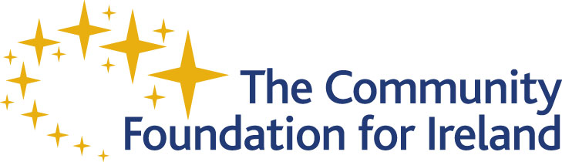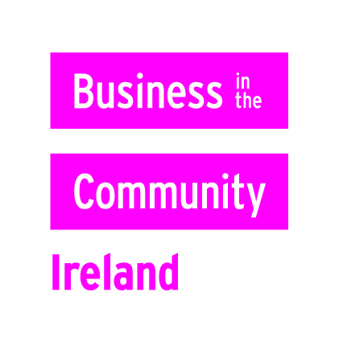

Business in the Community Ireland is the country’s leading network on corporate social responsibility. Our sister agency, The Community Foundation for Ireland is a leading organisation dedicated to promoting and growing philanthropy in Ireland.
The Marketing Unit aims to communicate the work of the organisations to both internal and external stakeholders. The unit communicates through a number of channels from internal staff newsletters to public relations, online channels, events and seminars and publications. A key role of the marketing unit is to increase membership and awareness of CR advisory services, promote the work of the social inclusion programmes and to increase awareness and resulting endowment funds at CFI.

Job Title: | Marketing and Communications Executive
Job Purpose: | The Marketing and Communications Executive will be responsible for promoting and communicating the work of both organisations to the media, business, government and general public. The Marketing team comprises three people.
Reporting to: | Marketing Manager
Direct Reports: | Interns / volunteers on occasion

JOB DESCRIPTION

Primary Responsibilities:

- Present Business in the Community Ireland and Community Foundation for Ireland to media, government, business and other key contacts
- Collaborate with Marketing Manager on creation and implementation of communications strategy for both organisations
- Plan and implement comprehensive PR programmes for both organisations
- Author articles around our work or liaise with in-house colleagues in developing articles
- Maintain up to date media database
- Identify new media opportunities, pitch stories to the media
- Develop existing and new relationships with journalists
- Plan and implement all photo-calls
- Track media coverage
- Develop clear messaging for both organisations
- Communicate internally on press
- Develop key social media strategies around some areas of our work
- Maintain and contribute to our websites
- Event management support
- General marketing support as required
- To contribute to the development of the delivery plan for communications and implement accordingly

- To collaborate with the Marketing Manager in evaluating communications on an ongoing basis
- To effectively utilise existing resources and assist in securing new resources to meet campaign objectives.
- Maintain computerised records of activity
- To manage the resources available as efficiently as possible in meeting your objectives.
- To take responsibility for your own personal and professional development and continuously review your own skills and knowledge to improve your performance. Actively participate in identification of your own training and development needs, appropriate training and development activities, and the evaluation of those activities.
- Contribute to the induction and development of trainees, volunteers and new colleagues.

Secondary Responsibilities:

- A key role of the marketing unit is to increase membership of BITCI and to increase endowment funds at CFI.

PERSON SPECIFICATION

Education/ Qualification/ Knowledge:
- A relevant PR/Marketing qualification
- A good knowledge of the basic landscape of Irish business

Experience:
- At least three years experience in public relations

Competencies:
- Relationship building, networking and service excellence
- Communication and influencing
- Planning and results orientation
- Leadership
- Research and Analysis

Desired Qualifications and Knowledge:
- Knowledge of Corporate Responsibility
- Knowledge of Social Inclusion
- Knowledge of Philanthropy

Business in the Community Ireland/ The Community Foundation for Ireland is an equal opportunities employer and promotes a policy of continuous personal and professional development among its staff.

Business in the Community Ireland/ The Community Foundation for Ireland has a policy of interviewing candidates with disabilities who meet the essential criteria.

